VOIP lab experiment#9
Creating a welcome message in mp3 format

Installation and Repair of Telecommunications Equipment

Name of student:________________
Group Number:_________________
Date:_________________________

The purpose of the lab is to create a message in the wave format and to upload it on the message in PBX.

- https://elevenlabs.io/
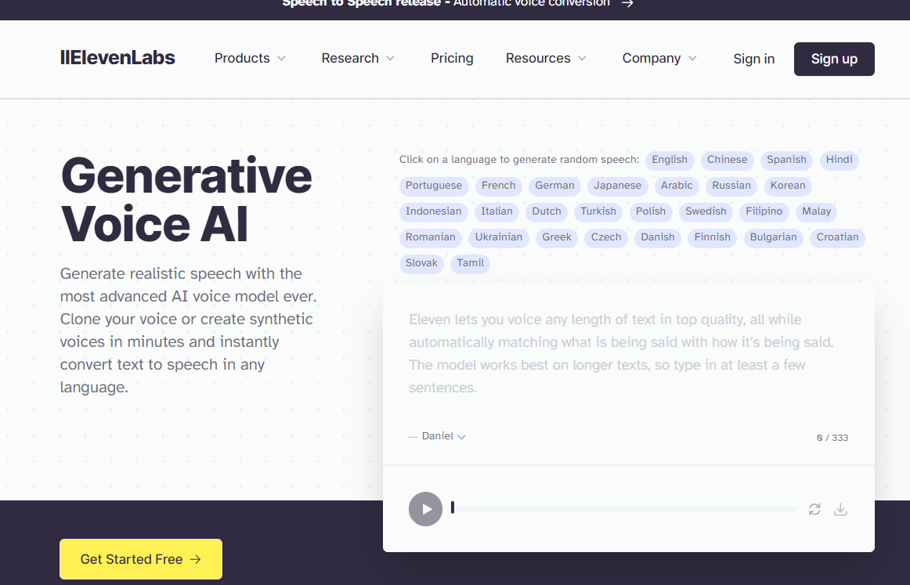

- Type your welcome message in the rectangle box. Once you complete your message click on download.
- Save the audio file in a location that you will be able to upload

